**Interfacing of 8087 Co-processor with 8086.**

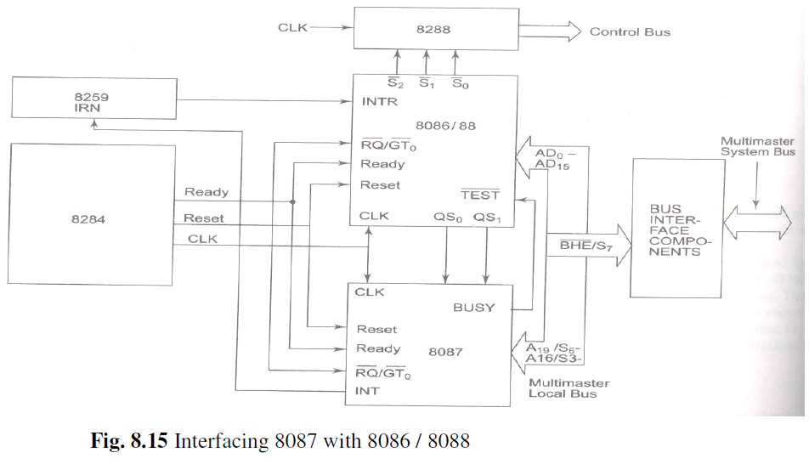

8087 can be connected to 8086 / 8088 only in their maximum mode of operation. In the maximum mode, all the control signals are derived using a separate chip called as a bus controller. The 8288 is a bus controller compatible with 8086 / 8088. The BUSY pin of 8087 is connected to the https://www.allsyllabus.com/aj/note/EEE/8086%20Microprocessor%20&%20Peripherals/Unit%208_IT/13.PNGpin of the CPU. The QS0 and QS1 lines may be directly connected to the corresponding pins in the case of 8086 /8088 based systems.The clock pin of 8087 is connected to clock input of CPU. The interrupt output of 8087 is connected to the CPU through a Programmable Interrupt Controller 8259. The pins AD0 – AD15, https://www.allsyllabus.com/aj/note/EEE/8086%20Microprocessor%20&%20Peripherals/Unit%208_IT/12.PNG/ S7, RESET, A19 / S6 – A16 / S3 of 8087 are connected to the corresponding pins of the CPU.